**Question 5: 10 Points**

1. **Find the minimal DFA of the following.**

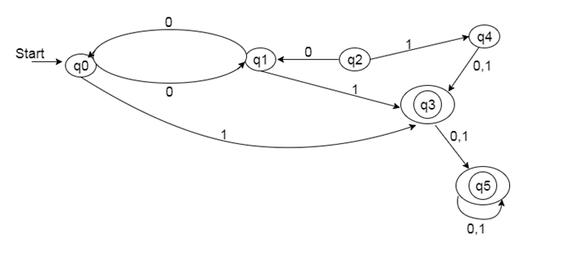

1. **Find the minimal DFA of the following.**

